**Spring Data JPA - Quick Example**

**Code:**

**OrmlearnApplication.java :**package com.cognizant.ormlearn;

import org.springframework.boot.SpringApplication;

import org.springframework.boot.autoconfigure.SpringBootApplication;

import org.springframework.context.ApplicationContext;

import org.springframework.boot.autoconfigure.domain.EntityScan;

import org.springframework.data.jpa.repository.config.EnableJpaRepositories;

import com.cognizant.ormlearn.model.Country;

import com.cognizant.ormlearn.service.CountryService;

import java.util.List;

*@SpringBootApplication*

*@EntityScan*(basePackages = "com.cognizant.ormlearn.model")

*@EnableJpaRepositories*(basePackages = "com.cognizant.ormlearn.repository")

public class OrmLearnApplication {

private static final org.slf4j.Logger *LOGGER* = org.slf4j.LoggerFactory.*getLogger*(OrmLearnApplication.class);

private static CountryService *countryService*;

public static void main(String[] args) {

ApplicationContext context = SpringApplication.*run*(OrmLearnApplication.class, args);

*LOGGER*.info("Inside main");

*countryService* = context.getBean(CountryService.class);

*testGetAllCountries*();

}

private static void testGetAllCountries() {

*LOGGER*.info("Start");

List<Country> countries = *countryService*.getAllCountries();

for (Country country : countries) {

*LOGGER*.debug("Country: {}", country);

}

*LOGGER*.info("End");

}

}

**Country.java :**package com.cognizant.ormlearn.model;

import javax.persistence.Column;

import javax.persistence.Entity;

import javax.persistence.Id;

import javax.persistence.Table;

*@Entity*

*@Table*(name = "country")

public class Country {

*@Id*

*@Column*(name = "code")

private String code;

*@Column*(name = "name")

private String name;

public String getCode() {

return code;

}

public void setCode(String code) {

this.code = code;

}

public String getName() {

return name;

}

public void setName(String name) {

this.name = name;

}

*@Override*

public String toString() {

return "Country [code=" + code + ", name=" + name + "]";

}

}  
**CountryRepository.java :**package com.cognizant.ormlearn.repository;

import org.springframework.data.jpa.repository.JpaRepository;

import org.springframework.stereotype.Repository;

import com.cognizant.ormlearn.model.Country;

*@Repository*

public interface CountryRepository extends JpaRepository<Country, String> {

}

**CountryService.java:**package com.cognizant.ormlearn.service;

import java.util.List;

import javax.transaction.Transactional;

import org.springframework.beans.factory.annotation.Autowired;

import org.springframework.stereotype.Service;

import com.cognizant.ormlearn.model.Country;

import com.cognizant.ormlearn.repository.CountryRepository;

*@Service*

public class CountryService {

*@Autowired*

private CountryRepository countryRepository;

*@Transactional*

public List<Country> getAllCountries() {

return countryRepository.findAll();

}

}

**Output:**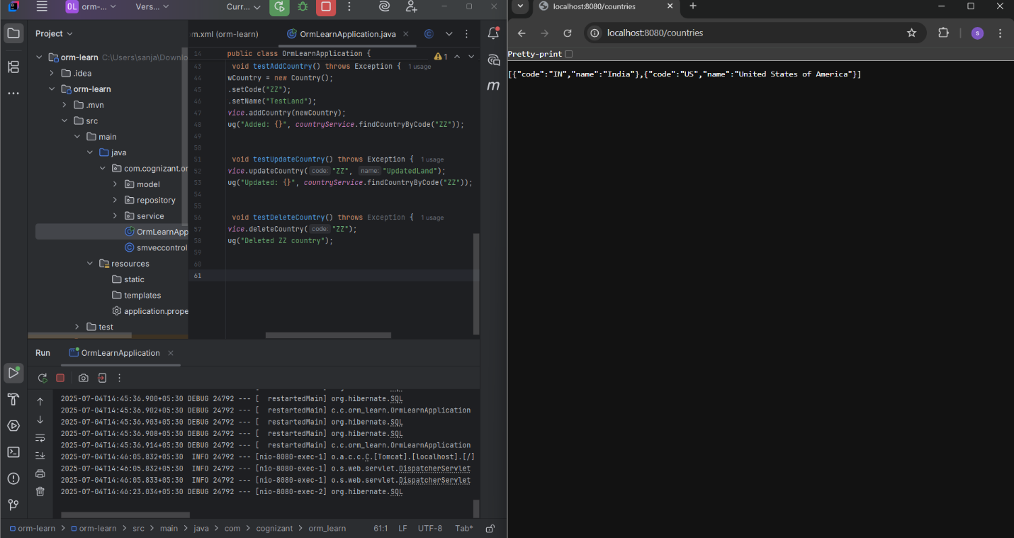

**Difference between JPA, Hibernate and Spring Data JPA**

**Code:**

**EmployeeController.java:**  
package com.example.employee_app.controller;

import com.example.employee_app.model.Employee;

import com.example.employee_app.service.EmployeeService;

import org.springframework.beans.factory.annotation.Autowired;

import org.springframework.web.bind.annotation.*;

@RestController

@RequestMapping("/employees")

public class EmployeeController {

    @Autowired

    private EmployeeService employeeService;

    @PostMapping("/add")

    public String addEmployee(@RequestBody Employee employee) {

        employeeService.addEmployee(employee);

        return "Employee saved successfully!";

    }

    @GetMapping("/test")

    public String test() {

        return "Test working!";

    }

}

**Employee.java:**  
package com.example.employee_app.model;

import jakarta.persistence.Entity;

import jakarta.persistence.GeneratedValue;

import jakarta.persistence.GenerationType;

import jakarta.persistence.Id;

@Entity

public class Employee {

    @Id

    @GeneratedValue(strategy = GenerationType.IDENTITY)

    private Integer id;

    private String name;

    private String department;

    private double salary;

    public Integer getId() {

        return id;

    }

    public void setId(Integer id) {

        this.id = id;

    }

    public String getName() {

        return name;

    }

    public void setName(String name) {

        this.name = name;

    }

    public String getDepartment() {

        return department;

    }

    public void setDepartment(String department) {

        this.department = department;

    }

    public double getSalary() {

        return salary;

    }

    public void setSalary(double salary) {

        this.salary = salary;

    }

}

**EmployeeRepository.java:**  
package com.example.employee_app.repository;

import com.example.employee_app.model.Employee;

import org.springframework.data.jpa.repository.JpaRepository;

public interface EmployeeRepository extends JpaRepository<Employee, Integer> {

}

**EmployeeService.java:**  
package com.example.employee_app.service;

sssssSSimport com.example.employee_app.model.Employee;

import com.example.employee_app.repository.EmployeeRepository;

import org.springframework.beans.factory.annotation.Autowired;

import org.springframework.stereotype.Service;

import org.springframework.transaction.annotation.Transactional;

@Service

public class EmployeeService {

    @Autowired

    private EmployeeRepository employeeRepository;

    @Transactional

    public void addEmployee(Employee employee) {

        employeeRepository.save(employee);

    }

}

**EmployeeAppApplication.java:**  
package com.example.employee_app;

import org.springframework.boot.SpringApplication;

import org.springframework.boot.autoconfigure.SpringBootApplication;

@SpringBootApplication

public class EmployeeAppApplication {

    public static void main(String[] args) {

        SpringApplication.run(EmployeeAppApplication.class, args);

    }

}

**Output:**  
